36.26: The third bright band is missing because the first order single slit minimum occurs at the same angle as the third order double slit maximum.

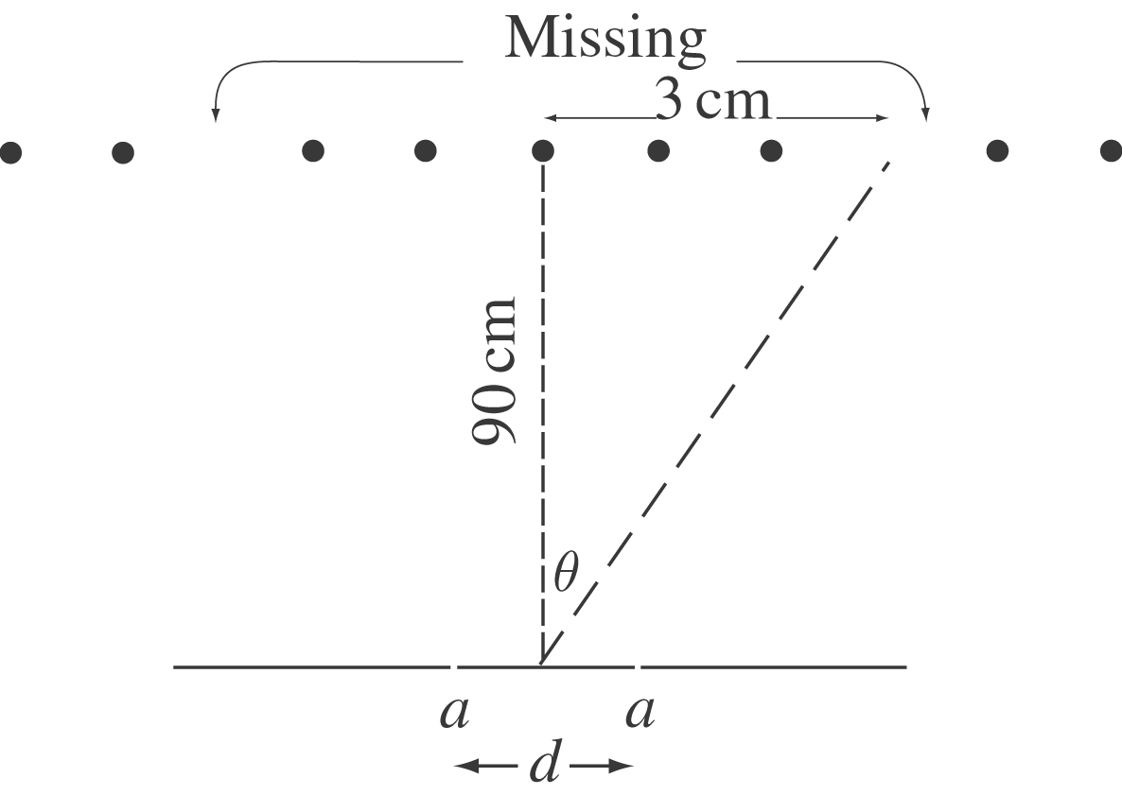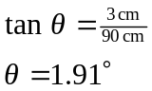

Single-slit dark spot: 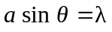
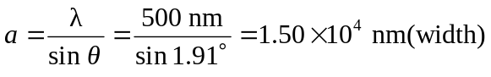
Double-slit bright fringe:
